APEX HIGH ALTITUDE BALLOON PROJECT FROM SUTTON GRAMMAR SCHOOL LAUNCH ON 22ND OCTOBER 2011 FROM CAMBRIDGE

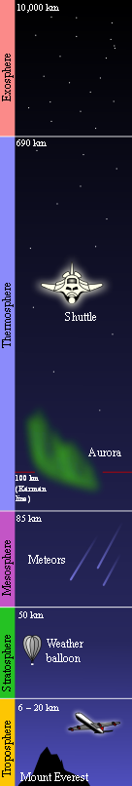
Background
The Apex High Altitude Balloon Project aims to use meteorological balloons to take photographs, capture video and collect sensor data from near-space. To date there have been two versions of Apex and three launches in total. On the 22nd October 2011 at 11am there will be a fourth launch with a new, very light payload; the aim is to break the current UK amateur altitude record for a weather balloon flight.

Weather balloons typically reach altitudes of 120,000ft, beyond the troposphere and into the stratosphere; this is 3½ times the altitude of a commercial aeroplane. The ApexHAB team aim to exceed this height and reach 4 times the altitude of a commercial flight.
The Apex High Altitude Balloon Project has been running since September 2008. It is being run by pupils at Sutton Grammar School for Boys. The boys running the project range in age from 15-17 and are named: Priyesh Patel, Daniel Saul, Edward Branford, Philip Warren, Alex Landless and Michael Woodgate.
Funding
The Balloon has been completely self built by pupils in the school and has been funded by the Institute of Physics, Virgin Galactic, AFCEA (Armed Forces Communications and Electronics Association.) and the Dorking and District Radio Society.

Previous achievements
Previous launches’ data and photographs are available online at www.apexhab.org including photographs and video footage of sunrise taken above 90,000ft. At this altitude the layers of the Earth’s atmosphere are clearly visible.

Future work
The team will be entering into the National Science and Engineering Competition and will be launching again in March carrying instruments capable of measuring Radiation levels at varying altitudes.

